Subject: Artwork for SHOP NOW

Date: 14 January 2018

**Select a Frame**

* Picture two frames, Ray-Ban aviator and a generic aviator. For example, the following two photos will work until better ones can be taken.

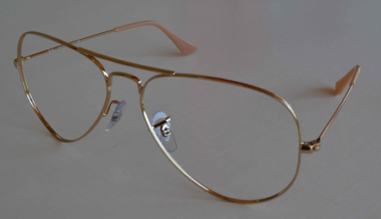 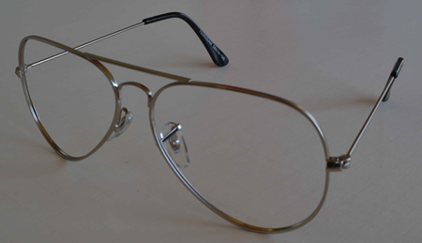

Ray-Ban® aviator frames Generic aviator frames

Available in gold, black, and other colors Available in silver and gold

$113 $7.50

Artwork

Ray-Ban-180415b-aviator.JPG Generic-180415b-aviator-TD3025.JPG

(Dexter – there needs to be a reference to the ®,  
“Ray-Ban is a registered trademark of the Luxottica Group S.p.A.”))

180415: Dexter – these are my notes. Modification to frame photos include the following:

1. Photograph frames without lenses
2. Set the frames exactly where they are to be photographed so they come out he same size

**Select Lenses**

* Picture three types of lenses: plano or single vision, bifocal, trifocal

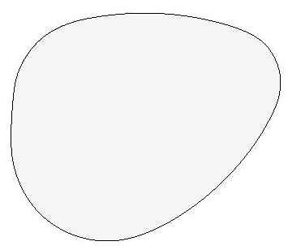 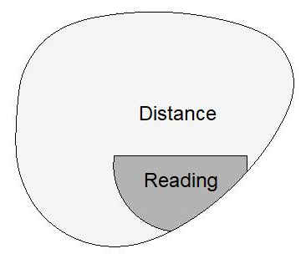 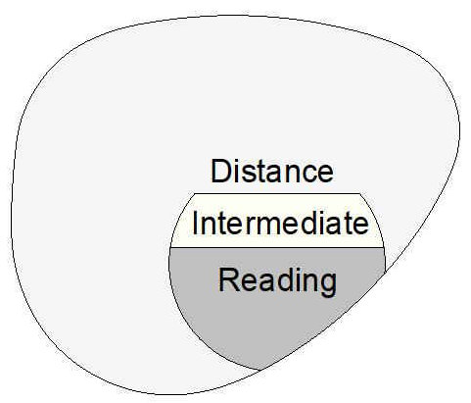

Basic Bifocal: Trifocal:

Plano: $24 FT28: $50 7x28: $68

Single Vision: $43 FT35: $64 8x35: $81

Others available Others available

Artwork

Lenses-180415-plano-b.jpg Lenses-180415-bifocal-b.jpg Lenses-180415-trifocal-b.jpg

**Select Tint Pattern**

* The tint pattern can either be tri-tinted or bi-tinted and is placed onto the lens appropriately for the field of view.

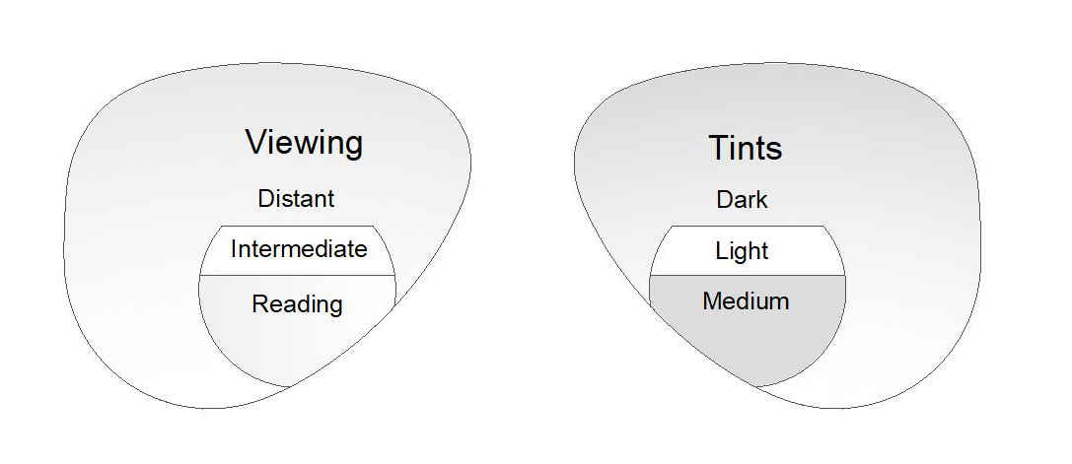

Tri-tinted: $75 (the distant area on the lens has a dark tint, the intermediate area has a light tint or is clear, and the reading area has a medium tint.)

Bi-tinted: $75 (the distant area on the lens has a dark tint, the intermediate and reading areas have the same tint which is usually clear.)

Artwork:

Tinting&Type-180113b-drawing.jpg

Example of a tri-tinted lens and a bi-tinted lens

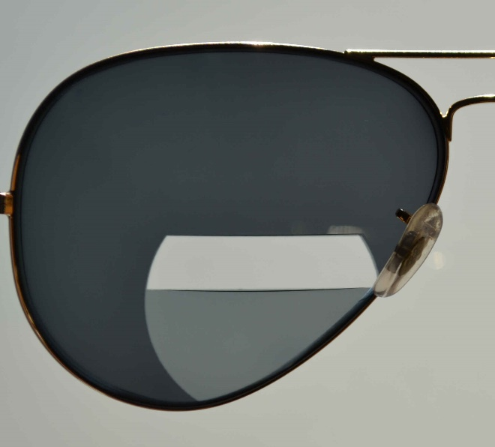 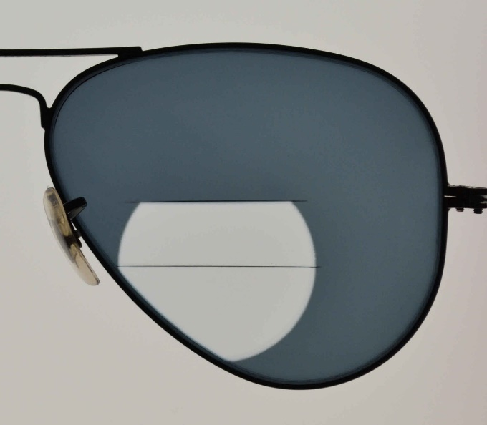

Skysight tri-tinted lens Skysight bi-tinted lens

Artwork:

SN159-160402c.JPG

SN371-171214d.JPG